**Project Design Phase – II**

**Data Flow Diagram & User Stories**

|  |  |
| --- | --- |
| **Date** | 13 November 2023 |
| **Team ID** | Team-593147 |
| **Project Name** | Predicting Mental Health Illness Of Working Professionals Using Machine Learning |
| **Maximum Marks** | 4 Marks |

**Data Flow Diagrams:**

A Data Flow Diagram (DFD) is a traditional visual representation of the information flows within a system. A neat and clear DFD can depict the right amount of the system requirement graphically. It shows how data enters and leaves the system, what changes the information, and where data is stored.

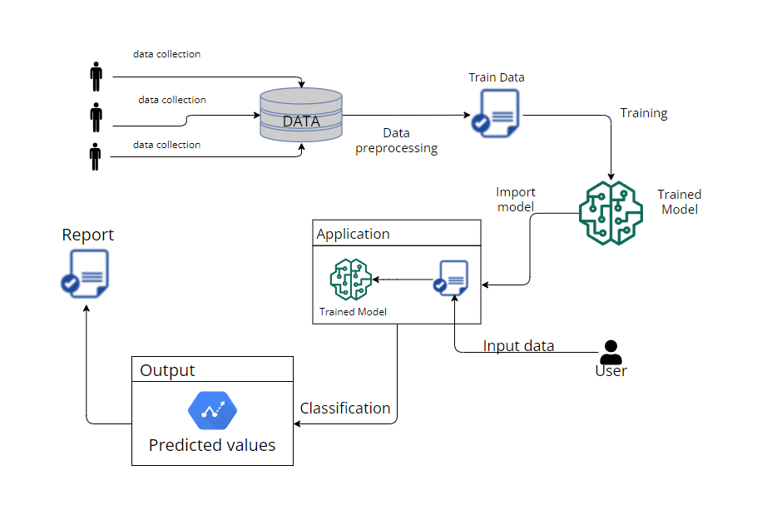

**User Stories:**

|  |  |  |  |  |  |  |
| --- | --- | --- | --- | --- | --- | --- |
| **User Type** | **Functional**  **Requirement**  **(Epic)** | **User Story**  **Number** | **User Story / Task** | **Acceptance criteria** | **Priority** | **Release** |
| HR Manager | Data Upload | USN - 1 | As an HR Manager, I want to upload employee survey data easily so that the system can analyse and predict mental health statuses based on the collected information. | The system should provide a user-friendly interface for HR Managers to upload CSV files containing employee survey data. | High | Sprint - 1 |
| Data Scientist | Data processing | USN - 2 | As a Data Scientist, I want to access and preprocess raw data efficiently so that the machine learning model can be trained on clean and relevant data. | The Data Preprocessing Module should provide a command-line interface for data scientists to access raw data. | High | Sprint - 1 |
| System Administrator | Monitoring and Alerts | USN - 3 | As a System Administrator, I want to monitor the system's performance and receive alerts for potential issues so that I can ensure the reliability of the mental health prediction system. | The system should log key performance metrics, including data processing time and model training time.  A monitoring dashboard should display real-time system performance. | High | Sprint - 2 |
| Mental health professional | Evaluation Metrics | USN - 4 | As a Mental Health Professional, I want to review the evaluation metrics and model performance to ensure the accuracy and reliability of mental health predictions. | The Evaluation Module should provide a dashboard displaying key model metrics, including accuracy, precision, recall, and F1 score. | Medium | Sprint - 2 |
| Employee | Well-being Feedback | USN - 5 | As an Employee, I want to receive timely and confidential feedback on my mental health status so that I can take proactive steps to maintain my well-being. | The User Interface Module should provide a secure login for employees to access their personalized well-being feedback.  Upon login, employees should see a clear visualization of their predicted mental health status along with an explanation of contributing factors. | High | Sprint - 3 |
|  |  |  |  |  |  |  |